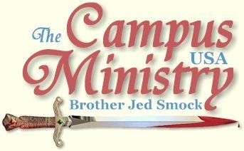
brojed.org
brojed@aol.com
573-999-0347
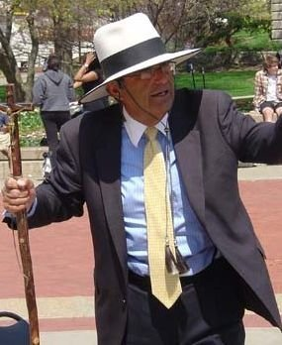

Dave M., the atheist, agreed to debate me at our open house next Friday, April 16. Please pray that God will draw a large crowd. Cindy will be fixing a turkey and pork roast dinner with her specialty gravies. We are anticipating our largest gathering ever with the added attraction of the debate.

All the photos in this email journal were take at Mizzou on Friday.

DO WE REALLY BELIEVE IN HIS RESURRECTION?

University of Missouri, April 5, 2010,
Second Day of Eastertide

Our church was packed yesterday for Easter; folding chairs had to be set up in the aisles. I am sure this was the case in other churches in Columbia as Christendom celebrated the Resurrection of our Lord. I wondered, “Where is everyone today to declare that He has risen?” I asked passing students this very question. “Why are not believers declaring his resurrection one day later? Do they really believe what they claim to believe?” I proposed, “If you were at the funeral of your grandfather yesterday and suddenly just before the casket was closed he rose from his coffin and declared, ‘I am alive,’ would you not be telling everyone? Would not it be something you declared to everyone for days, weeks, months and years after the wondrous event?”

Only about 6-8 people gathered for the first two hours as I proclaimed the good news. I supposed most either did not believe that Christ is alive or they just did not care. One man, Dave M., whose father was Roman Catholic and mother Jewish had many thoughtful questions. He once played in a band in a local evangelical church of 1000 members but he had lost his faith. He was polite and soft spoken and shook my hand after almost two hours of questioning me. Several students shook my hand and welcomed me back. Tanya who is an old regular on the Circle questioned me concerning why God required atonement to forgive sins. I have explained this to her in the past but she does either does not understand or she does not accept my explanation.

I pointed out the trees are just budding after the long winter which is a testimony to Christ’s resurrection, which gives us hope of our own resurrection. Martin Luther said, “Our Lord has written the promise of the resurrection, not in books alone, but in every leaf in spring-time.” No one seemed impressed. My, my how sin blinds men to the beauty of nature and hence to the glory of God.

From about 2-3 the crowd reached from up to 25. I had a long talk with one student about the fact that he was dressed like a bum with holes in his jeans which is not appropriate for an academic setting. I also rebuked the students for their cussing and constant use of slang. Their basic reply is the clothes and words mean nothing. To me it all has to do with human dignity. Man’s ability to express ideas in words sets him off from the animals. But of course they think they are merely animals, so why not just bark at one another like dogs and grunt like animals?

By 3:20 most everyone had left; I decided to call it a day. I expect things to pick up the rest of the week as students get settled back in after just returning from Spring Break. However, I do not anticipate the Christians getting excited enough about the Resurrection to publicly declare the miraculous event. Personally I am as excited as ever about the fact that the tomb is empty and I intend to declare it unto the end of my age.
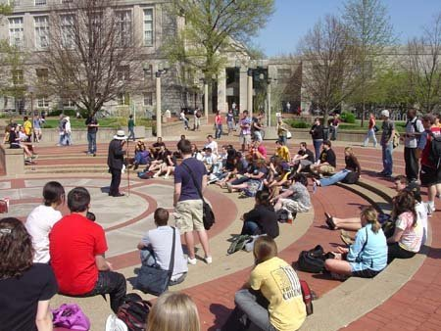
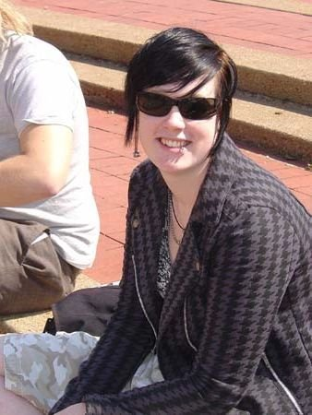
A Heckler
SPRING BREAK DRUNKEN FATALITY

University of Missouri, April 6, 2010, Third Day of Eastertide,
Since the students have been returning from Spring Break, I opened today by telling the story of 17 year old Matt James, a 6 ft. 6 inches, 290 pounder, who had been recruited to play football for Norte Dame. He went to Florida for Spring Break and checked into the Day’s Inn. Witnesses and friends indicate he became drunk and belligerent. He leaned over the balcony rail and shook his finger at the people in the next room over. Then he fell over the rail to his death. The mother of the high school team quarter back claimed that Matt was a wonderful and good kid. Not so, Matt was a drunk and when his body hit the concrete his soul fell into the abyss of Hell. He was the second person to fall from a balcony to his demise in Panama City this Spring Break. These incidents happen every year at Spring Break.
I told the students that I was glad that they made it home safely from Spring Break. I urged them to be checking themselves for outbreaks of STD’s. I warned them that if they continued in their drunken partying ways they would never return from the flames of Hell. I related Matt’s story at each class break, the students had little response to my telling of the gruesome incident. The incident substantiated the truth of the Proverb that “wine is a mocker, strong drink is raging and whosoever is deceived thereby is not wise.”
I did have more people than yesterday gather but still attendance was lower than usual at Mizzou. My friend, Rocket, a local musician, came to campus about 2 PM. After I gave a 20 minute sermon on the death and resurrection of Jesus, I called on Rocket who gave a fifteen minute exhortation and witness to the students. He remarked to the students concerning their apathy.
Earlier, I read most of Roman 2 to the students commenting as I read. Romans 2:5 is relevant to the attitude of many of the ones who have gathered the last two days: “After thy hardness and impenitent heart thou treasurest up unto thyself wrath against the day of wrath and revelation of the righteous judgment of God.” An impenitent heart is a will that becomes even more stubborn and unrepentant after light as been cast upon the sinner. But the impenitent heart rejects the light and goes further into darkness.
Despite the general indifference, I did succeed in provoking some good conversation and motivate a couple of Christians to witness. After I had questioned a skeptical philosophy student for a while, a girl moved from the other side of the circle and sat down beside him and opened her Bible and began reading and witnessing. Evidently, she thought that she could do the job better than I. She did capture his attention and soon drew another evident believer into the conversation. I decided to take a break until the next class break since there were only a few students around and let the girl get some experience at witnessing.
When I left campus at 3:30, Rocket was instructing a Christian as to how to effectively witness.
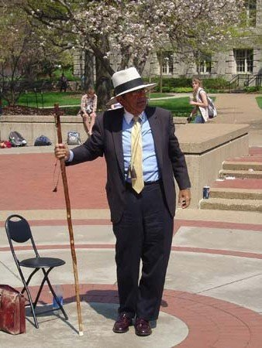
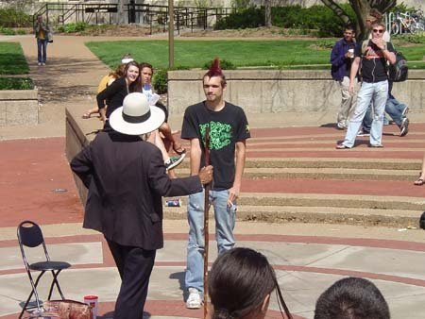
REASONS MEN FAIL TO BELIEVE
University of Missouri, April 7, 2010,
Fourth Day of Eastertide,
The weather was overcast when I started at the noon break. I did not seem to be getting much attention so half way through the break when Dave M., the former band member at a large Evangelical Church and now skeptic, approached me with questions I gave him my attention. He is reading a Jesus, Interrupted by an alleged N.T. scholar, Bart D. Ehrman. Dr. Ehrman is an apostate, who strains at gnats (alleged contradictions) in the Bible. There is nothing new in his book which is representative of the so-called higher criticism of the Bible which comes out of 19th Century Germany. Judgment came to Germany in the 20th Century.
I quizzed Dave as to whether he was ever actually converted when he was in church. He spoke of some warm feeling he had one time, but nothing of repentance and true faith. A female joined our conversation which last for most of the hour. However, at the next break I started preaching again and the female took Dave aside to continue their conversation.
I did draw a crowd of 25-30 which pretty much stayed in that range until 4 PM when I granted an interview in the Law Building to three journalism students. They wanted my opinion concerning the City Council recently granting benefits to same sex couples.
Rocket came out again today and spoke for 15 minutes and then followed it up with a long witness to a pre-med student. I spent almost an hour on what constitutes normal sexual relations. Dave M. stayed around for much of the afternoon straining at Biblical gnats but ignoring the weightier matters of the Bible: justice, mercy, salvation, atonement, etc. There was a 25 years old atheist who claimed to have once been a believer but he could not give me a reason for either his earlier faith or a reason for departing from the faith. He was offended when I suggested his motive for rejecting Christianity was in order to indulge in the lusts of the flesh.
In the evening I taught Cindy’s Christian Home Educators Wednesday night Bible Study on the subject of apologetics. I gave three reasons why people do not believe: 1. Men are unwilling to believe because faith requires them to forsake their sins. 2. Failure of Christians to present the evidence carefully, rationally, and effectively. 3. Failure of believers to exhibit the kind of character unbelievers expect followers of a Holy God to display.
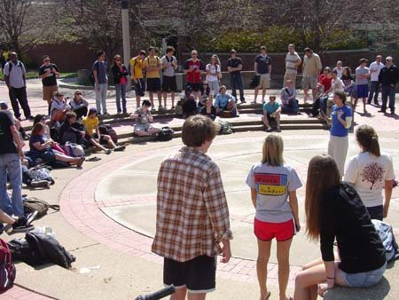
Sister Cindy

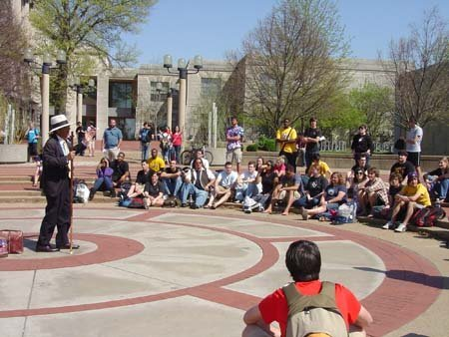

UNDER THE WEATHER

University of Missouri, April 8, 2010,
Fifth Day of Eastertide,

I caught a bad cold yesterday afternoon. At the noon break I did not have the energy to preach and draw an audience. I stood at the center of the circle with my staff crucifix and announced Jesus’ resurrection to passing students. Not only was there the problem of my cold, but the weather, although sunny, was only in the fifties with a strong wind. The campus radio station was also playing loud decadent music. I went back to my car to take a nap. I returned at 1 with my YOU DESERVE HELL sign. There were not many students passing by but several negatively acknowledged my sign. After 15 minutes I decided to go home. At least I gave it the old college try.

Before I started at noon, a student from the radio station apologized if the music was too loud. He said he was promoting the station, but he was unable to tune the music lower. I had a pleasant conversation with him and invited him to our open house on April 16. He was simply asking me about my other interests. Sometimes it can be productive just to have light conversation with students which may open them up later to hear the preaching.
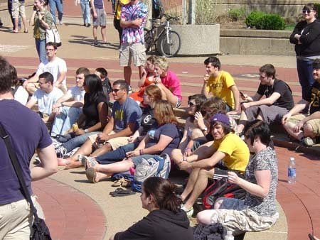

University of Missouri, April 9, 2010,
Sixth Day of Eastertide,

My cold was somewhat better, but I was still in a weakened condition. I was trusting in Paul’s testimony, “When I am weak then am I strong.” We came completely out from under the cold weather as it was 70, sunny and only a light wind. As I sat in the center of the circle waiting for the class break a philosophy student asked me, “What is the word of the Lord.” I gave a 2 minute gospel message. He indicated that he had to go to class. I asked him, “What is the class?”
He answered, “The Philosophy of the Mind.” We had a lively discussion on determination vs. freedom. I taught that the physical body including the brain itself is under the law of cause and effect. The mind is free to choose between good and bad influences. The mind and will and conscience are our moral faculties. The brain is the instrument of the mind uses to express itself. The mind is our soul or spirit. I did not notice that he went to class. A number of students were involved in the discussion.

I was able to keep the students’ minds in their craniums for about two hours. The first hour we talked mostly about the mind and its relationship to the body. The second hour I presented a lengthy account of the story of my conversion. Usually, especially on Friday, their minds are in their genitals. For most of that time I had an audience of 20-25, Dave, the atheist, mostly just listened. He also passed though the crowd passing out a tract, “It’s Okay To Be An Atheist!” I also argued that Christianity gives us the most reasonable, intelligent and hopeful answers to the basic questions and issues of life compared to other religions or philosophies.
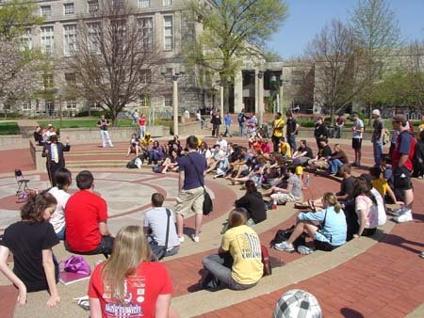

Cindy arrived about 2:15 and I called on her at 2:30. It was her first time out this spring. In her dramatic way she slowly built up the crowd. A group of friends, who last fall sat in the inner circle as I preached, all this week visited in the outer circle and took little account of my preaching. However, Cindy’s speaking drew them into the inner circle. At the 3 PM break a crowd of close to one hundred gathered. Most of them stayed on for quite some time. Cindy left campus shortly around 4 PM. I continued with the students mostly defending the free market against their socialists’ views. Much of the time was spent on Obama Care. Slowly the crowd dwindled; at 5:15 I decided to call it a day since there were only about 10 left. It was my best day of the week. It is very difficult to convince them that there are alternatives to solving economic and social problems other than governmental solutions.
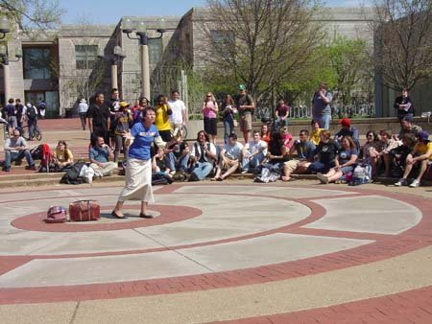
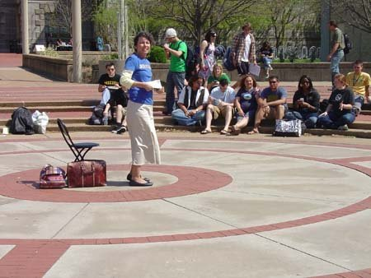

Dave M., the atheist, agreed to debate me at our open house next Friday, April 16. Please pray that God will draw a large crowd. Cindy will be fixing a pork roast dinner with her specialty gravy. We are anticipating our largest gathering ever with the added attraction of the debate.

April 11, the eighth day of Eastertide, I received an email from Carl Giordano telling of his witness of passing out tracts and preaching at the Fort Worth Arts Festival. I responded, “Great report, Carl. It is good to know you are still on the firing line after all these years.” Carl wrote me back:
Thank you. Yes, I got saved 37 years ago, at the age of 24 in 1973.

Went to Christ For The Nations in 1975....Holy Hubert came and preached in chapel etc.
I was glued to my seat in excitement and suspense....I sensed the Holy Spirit saying to me--- "What Hubert does I want you to do."
But, I thought myself much to SCARED TO DEATH to ever do that.....so I didn't do it.........

Then after a semester I quit school...went back to Pennsylvania. In 1979 I went back to Christ For The Nations and graduated December 14, 1980.....But, this time, while at school, an even WILDER GUY THAN HUBERT SHOWS UP AND IS PREACHING AND TESTIFYING ABOUT THE CAMPUS MINISTRY etc. etc. etc.

I was ARRESTED again by the Holy Spirit. This time I felt as though God had me by the scruff of the neck and that He was saying---- "Are you going to OBEY ME, or am I going to have to HURT YOU ?! "

Well, the rest is history.

Oh, I forgot to give you the name of that other WILD fellow that God used to influence me ( FORCE ME ) to start preaching on campuses, streets, etc.. . It was---JED SMOCK !!!!!!!!!!!!!!

Have you ever heard of him ? Oh well, I guess he's somewhere --- PREACHING UP A STORM !
Thank You Much
On April 1, Bro. Jed returned from his three month winter mission to the campuses of America. He preached from Florida to California and back to Missouri. Thanks to you, our supporters, and the grace of the Lord, we do not have one penny of debt from the expense of the long trek west. We could not do this without the sacrifice and generosity of all of you. We appreciate you and thank you for giving to CMUSA. When the students ask how we get our money, we tell them that many Christian people love them and care about their souls and therefore provide the funds for us to preach the Gospel.
Bro. Jed will be ministering daily in Missouri for the next four weeks. In early May, he goes to campuses in Ohio for two weeks and then he will spend the last 4 weeks of 2009-2010 preaching in the Northwest. Again, the expenses will be great, but we trust the Lord to provide. You may donate to CMUSA by mailing to our home office at 2402 Longview Dr., Columbia, Missouri or through Pay Pal by going to our web site, brojed.org. Gifts are tax deductible.
II Cor.9:7 Every man according as he purposeth in his heart, so let him give; not grudgingly or of necessity; for God loveth a cheerful giver.
There are some recent preaching videos on our new web site. One of the videos is of Bro. Jed’s debate with the Episcopal priest at UA. Another is his address to the atheist group at ASU. Download them free and share with friends and family.
Let us hear from you. On Christ, Sis. Cindy

